**FACIAL EMOTION DETECTION**

Submitted in partial fulfillment of the requirements for the award of degree of

**BACHELOR OF ENGINEERING**

**IN**

**COMPUTER SCIENCE & ENGINEERING**

**Submitted to: Submitted By:**

**Mrs. Anchal Singh**

**DEPARTMENT OF COMPUTER SCIENCE & ENGINEERING**

**College Name**

**JUNE 2020**

**ACKNOWLEDGEMENT**

Before we get into the intricacies of the project, I would like to add a few heartfelt words for all those who knowingly or unknowingly became a part of this project in numerous way, those who gave unending and unconditional support right from the stage the idea was conceived.

Foremost, I would like to express my sincere gratitude to my Training incharge **Mrs. Neetu Batra** for her continuing interest, encouragement and valuable guidance throughout the course of work.

Words fail to express my feeling of thankfulness towards my **parents and friends** for their ever-available co-operation, encouragement and love throughout this work. Above all, I express my profound gratitude to the Almighty for all this grace & light, which gave strength & encouragement as I moved with this venture at last stage.

**GOURAV SHARMA**

## (17BCS1006)

## ABSTRACT

This is a Project Report on “FACIAL EMOTIONS RECOGNITION” which is developed using python language. During the making or Development of the project we explored new ideas and libraries in python for implementing GUI based Application.

The Project is the output of our planning, schedule, programming skills and the hard work, and this report reflects our steps taken at various levels of programming skill, planning and schedule.

We have learnt a lot during this project in our coding skills and deep concept related to these kinds of projects.

It recognizes face and produces output by understanding face using different modules.

**Table of Contents**

**CHAPTER: 1**

**INTRODUCTION TO COMPANY………………………………………………………...1**

**CHAPTER: 2**

**INTRODUCTION TO PROJECT………………………………………………………...2-3**

2.1 INTRODUCTION .........................................................................

2.2 PURPOSE OF THE PROJECT ............................................................

2.4 FEATURES OF THE PROJECT........................................................................

**CHAPTER:3**

**LITERATURE SURVEY ....................................................................................................4-5**

3.1 EXISTING SYSTEM ...............................................................................................

3.2 PROPOSED SYSTEM .............................................................................................

3.3 FEASIBILITY STUDY............................................................................................

3.3.1 ECONOMICAL FEASIBILITY ..........................................................................

3.3.2 TECHNICAL FEASIBILITY ...............................................................................

3.3.3 OPERATIONAL FEASIBILITY .........................................................................

**CHAPTER: 4**

**SYSTEM ANALYSIS AND DESIGN ...............................................................................6-10**

4.1 SYSTEM REQUIREMENTS .................................................................................

4.1.1 HARDWARE REQUIREMENT ..........................................................................

4.1.2 SOFTWARE REQUIREMENT ...........................................................................

4.2 FLOWCHART DIAGRAMS.....................................................................................

**CHAPTER: 1**

**INTRODUCTION TO COMPANY**

**SOLITAIRE INFOSYS PVT.LTD.**



Solitaire Infosys Pvt. Ltd. is an acclaimed IT service provider contributing its part in the development of many businesses around the globe. We socialize with our clients to get a superior cognizance of their business and requirements and help them in fabricating websites and applications for their business. Founded in 2011 by a dynamic duo with the same aim and zeal, we have come a long way in satisfying our clients. Infosys Technologies has been ranked as the tenth best company in terms of leadership. Infosys is the only Indian Company to be ranked among the Top 20 Companies in the world in this category. Infosys has a global footprint with 63 offices and development centers around the world. With 11,822 employees. It operates in different sectors such as: - Industries, IT services, Engineering services, consulting services, BPO services, a Product and Platforms. Solitaire company has three main offices in the world- In Canada, US, India.

**Directors:** Mr. Rajesh Sharma & Mr. Jogvinder Singh

[**Address**](https://www.google.com/search?biw=1366&bih=662&q=solitaire+infosys+address&stick=H4sIAAAAAAAAAOPgE-LWT9c3LEk3KzHKNtCSzU620s_JT04syczPgzOsElNSilKLiwG2Y6muLgAAAA&sa=X&ved=0ahUKEwicwbGCicjaAhUSSI8KHctNDvkQ6BMIywEwEA)**:** C-110, Industrial Area, Phase 7, SahibzadaAjit Singh Nagar, Punjab 160055

**CHAPTER: 2**

**INTRODUCTION TO PROJECT**

2.1 **INTRODUCTION**

It recognizes face and produces output by understanding face using different modules. Did you know that every time you upload a photo on facebook, the platform uses facial recognition algorithms to identify the people in that image or that certain government around the world use Facial Emotions Recognition technology around

The world uses Facial Emotion Recognition technology to identify and catch criminals. The best examples of the Facial Emotion Recognition of you can now unlock your Smartphone using your face. The applications of this sub-domain of computer vision are vast and businesses around the world are already reaping the benefits. The usage of Facial Emotion Recognitions models is only going to increase in the next few years.

The objective of Facial Emotion Recognition is to determine the sequence of faces units from the face so that the linguistic message in the form of text to be decoded from the scanning face .

facial recognition is a category of biometric software that maps an individuals’s facial feature mathematically and stores the data as a faceprint.The software uses deep learning algorithms to compare a live capture or digital image to the stored faceprint in order to verify an individual’s identity.

## 2.2 PURPOSE OF THE PROJECT

Facial Emotion Recognition is a method of identifying or verifying the identity of an indivisual using their face. Facial Emotion Recognition systems can be used to identify people in photos, videos , or in real-time. Law enforcement may also use mobile devices to identify people during police stops

**2.3 OBJECTIVE OF THE PROJECT**

The goal of this project is to detect and locate human faces in a colour image a set of seven training images were provided for this purpose.the objective was to design and implement a face detection in MATLAB that will detect human faces in an image similar to the training images.

## 2.4 FEATURES OF THE PROJECT

The project features are as follows:

* Watchlist as a service
* An airtight matching algorithm
* scalability
* built in privacy protection.
* Predictive analytics
* Easy to run and use (Just open cmd, browse to the project folder and run .py file).

**CHAPTER: 3**

**LITERATURE SURVEY**

**3.1 EXISTING SYSTEM**

We present a review on the most successful existing algorithm or methods for Facial Emotion Recognition technology to encourage researches to embark on this topic. The algorithm are principle component analysis (PCA), linear discriminant analysis(LDA), skin colour, wavelet and artificial neural network(ANN).

**3.2 PROPOSED SYSTEM**

Proposing a new combination of biometric system, gives very good feacture identification accuracy compared to the existing methods. In Facial Emotion Recognition to make changes in existing system scale invariant feature extraction.

**3.3 FEASIBILITY STUDY**

A feasibility study aims to objectively and rationally uncover the strengths and weaknesses of an existing business or proposed venture, opportunities and threats present in the environment, the resources required to carry through, and ultimately the prospects for success. In its simplest terms, the two criteria to judge feasibility are cost required and value to be attained.

A well-designed feasibility study should provide a historical background of the business or project, a description of the product or services accounting statements, details of the operations and management, marketing research and policies, financial data, legal requirements and tax obligations. Generally, feasibility studies precede technical development and project implementation. A feasibility study evaluates the project's potential for success; therefore, perceived objectivity is an important factor in the credibility of the study for potential investors and lending institutions.

This project can be implemented using affordable electronics and software technology making it economically, technically and operationally feasible.

**3.3.1 ECONOMIC FEASIBILITY**

This is a very important aspect to be considered while developing a project. We decided the technology based on minimum possible cost factor. All hardware and software cost has to be borne by the organization. Overall, we have estimated that the benefits the organization is going to receive from the proposed system will surely overcome the initial costs and the later on running cost for system.

To design music player as long as a computer has the Python development and the application development of Python is free. In addition, music player is basic needs for public for listening songs. The information that which functions are necessary form all the consumers, which functions are needed for some people, and which features are seldom to use is easy to understand. And a lot of research is eliminated, thus saved the spending. Therefore, the whole process of development doesn’t need to spend any money that is economic feasibility.

**3.3.2 TECHNICAL FEASIBILITY**

This included the study of function, performance and constraints that may affect the ability to achieve an acceptable system. To design a music player which meets the basic requirements, a deep understand of Python language, its packages, operations, GUI, application of framework and other technical knowledge are needed.(framework is the core of the application, and rules that all the programmers participating in the development must abide by). Based on the related technology information and resources for python on the market, and equipped with technical personnel of technology and the spirit of willing to learn, the technology is feasible.

**3.3.3 OPERATIONAL FEASIBILITY**

No doubt the proposed system is full GUI based that is very user friendly and all inputs to be taken all self-explanatory even to a layman. Besides, a proper training has been conducted to let know the essence of the system to the users so that they feel comfortable with new system has cut down their loads and doing.

**CHAPTER: 4**

**SYSTEM ANALYSIS AND DESIGN**

**4.1 SYSTEM REQUIREMENTS**

For this project minimum hardware and software requirement are listed below:

**4.1.1 Hardware Requirement**

**Processor** : Pentium 4 or above

**Processor Speed** : 2.00 GHz CPU

**RAM** : 1 GB or above

**Hard disk utilization:** : 300 MB or above

**4.1.2. Software Requirement**

**Front End** : Python

**Operation System** : Windows 8 or more

## 4.2 FLOWCHART DIAGRAMS / DFD’s

**4.2.1 real time flow diagram**

.

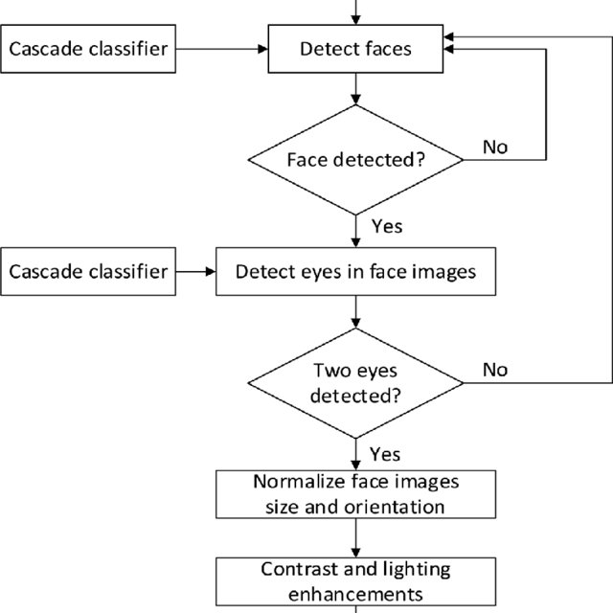

**4.2.2 Facial Emotion Recognistion security system**

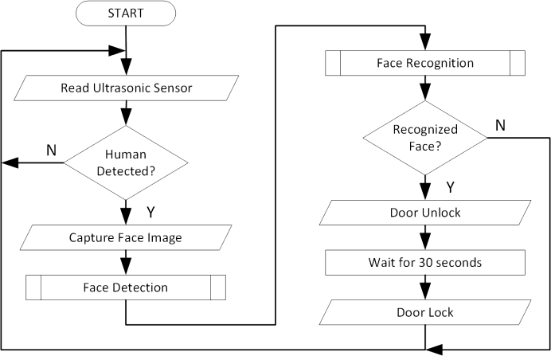

**4.2.3 Proposed recognition system**

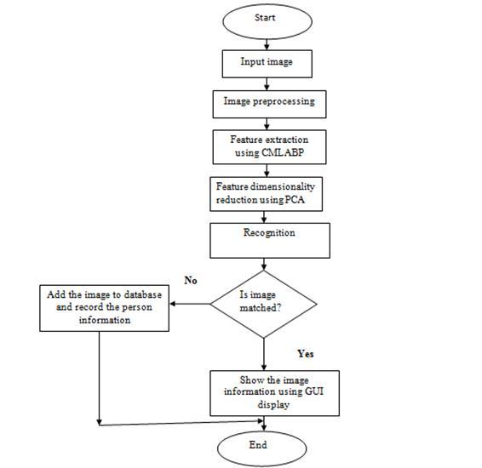

**4.2.4 Scintific diagram**

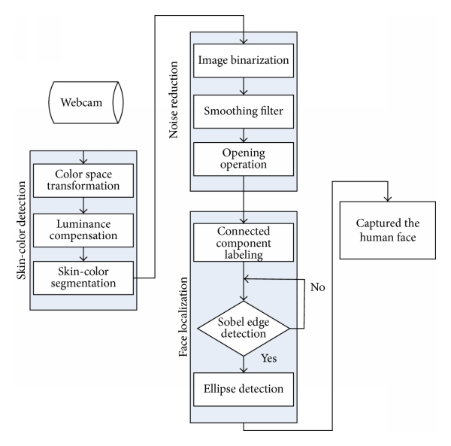

**4.3 METHODOLOGY/ PLANNING OF WORK**

Different steps were implemented during the preparation of the projects. The following methods were employed for “FACIAL EMOTIONS RECOGNITION”:

* **Sample survey: -** In this a brief research was made related on the project.
* **Information: -** Required information was collected from the different source such as web and different sources.
* **Opinion collection: -** Opinion related to the project was collected from different source such as friends and teachers.
* **In depth study: -** finally in-depth study was made related to the project. Different way of implementing the found resource was studied.
* **Programming: -**After all of the above programming is done.
* **Testing and maintenance: -** after programming testing and maintenance was done.

.

**4.4 MODULES OF THE PROJECT**

The system is proposed to have the following modules or forms:

1. **Main interface: -**Main interface implements all the basic commands for playback control like play, pause, stop, previous, next and volume control. It provides facilities to open previously saved play lists, show play list manager.

**It provides the following functionalities:**

Open Play List, ShowPlay list, play, pause, stop, previous, next, volume control and exit.

1. **Playlist Manager: -**This interface has a menu and a dynamically expandable table in scroll pane.

**The menu bar in this interface has following commands:**

File, New, Save, Save as, Exit, Edit, Add file(s), Add folder, Edit Tags,

1. **Remove File: -**It has a table which shows list of files that are currently in play list.

**Following metadata about mp3 files are shown in this table:**Serial Number, Track number, Track Title, Album, Artist, Time.

**7.2 FUTURE SCOPE**

Today, one of the fields that uses facial recognition the most is security. Facial recognition is a very effective tool that can help law enforcers recognize criminals and software companies are leveraging the technology to help users access their technology. This technology can be further developed to be used in other avenues such as ATMs, accessing confidential files, or other sensitive materials. This can make other security measures such as passwords and keys obsolete.

Another way that innovators are looking to implement facial recognition is within subways and other transportation outlets. They are looking to leverage this technology to use faces as credit cards to pay for your transportation fee. Instead of having to go to a booth to buy a ticket for a fare, the Facial Emotion Recognistion would take your face, run it through a system, and charge the account that you’ve previously created. This could potentially streamline the process and optimize the flow of traffic drastically. The future is here.